PHASE 3 – INCIDENT RECORD CREATION
Incident Lifecycle Automation in ServiceNow
Implementation Documentation with ServiceNow Screenshot Evidence

1. Phase Objective
The objective of Phase 3 was to create the main ServiceNow Incident record that would be used to demonstrate the end-to-end incident lifecycle. The selected business scenario was a user who could not connect to the company VPN even though internet connectivity was available.

2. Incident Record Created
The incident was created in the ServiceNow Developer Instance and received the number INC0010014. The record was prepared with the caller, incident category, service context, impact/urgency, and problem description required for the later lifecycle phases.
Field | Configured Value
Incident Number | INC0010014
Caller | Abel Tuter
Category | Network
Subcategory | VPN
Service | IT Incident Management Service
Service Offering | Standard IT Support
Channel | Self-service
Impact | 2 - Medium
Urgency | 2 - Medium
Priority | 3 - Moderate
Assignment Group | Network
Short Description | Unable to connect to company VPN
Description | User is unable to connect to the company VPN from their laptop. The user has confirmed that internet connectivity is available, but the VPN connection fails.

3. Screenshot Evidence
The following screenshot is the ServiceNow evidence for the incident record created in this phase. It shows the main incident number and the configured incident details used for the project.
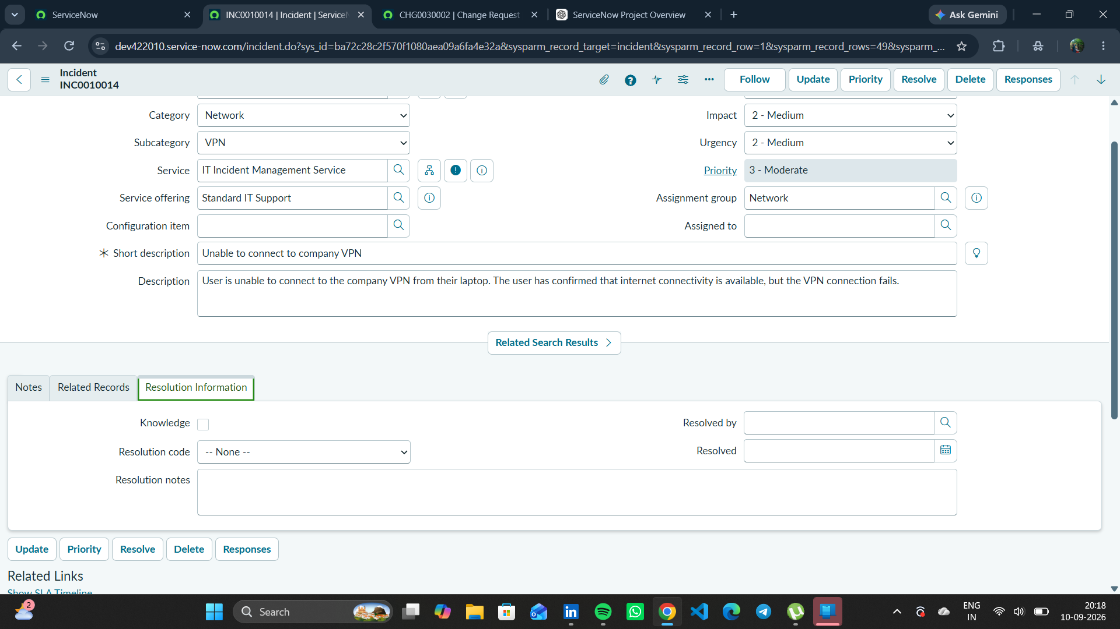
Figure 1. INC0010014 incident record showing the VPN incident details, service context, classification, impact, urgency, priority, and assignment.

4. Business Purpose
This incident serves as the parent record for the project demonstration. Subsequent phases use this incident to demonstrate Knowledge integration, Level 2 escalation and investigation, Emergency Change creation, child-incident tracking, and final resolution.

5. Phase 3 Outcome
- A valid ServiceNow Incident record was created as INC0010014.
- The incident was associated with the IT Incident Management Service and Standard IT Support offering.
- The VPN issue was captured with a clear short description and detailed problem description.
- Impact and urgency were set to Medium, resulting in Priority 3 - Moderate.
- The incident was ready for the classification, knowledge, escalation, and investigation phases.
Status: COMPLETED

6. Phase 3 Evidence File
- 01_INC0010014_Incident_Record.png

